Ideation Phase

Define the Problem Statements

|  |  |
| --- | --- |
| Date | 19 September 2022 |
| Team ID | PNT2022TMID37456 |
| Project Name | Personal Expense Tracker Application |
| Maximum Marks | 2 Marks |

**Customer Problem Statement Template:**

All people in the earning sector needs a way to manage their financial resources and track their expenditure, so that they can improve and monitor their spending habits. This makes them understand the importance of financial management and make better decisions in the future and decreases the likelihood of falling into debt or financial stress. All individual who earns needs a way to account and record their cash flow, without it there would be a lot of chaos on where and what the money is being spent on and how often. It provides a better way to efficiently manage their resources and make smart decisions for leading a better and successful life.

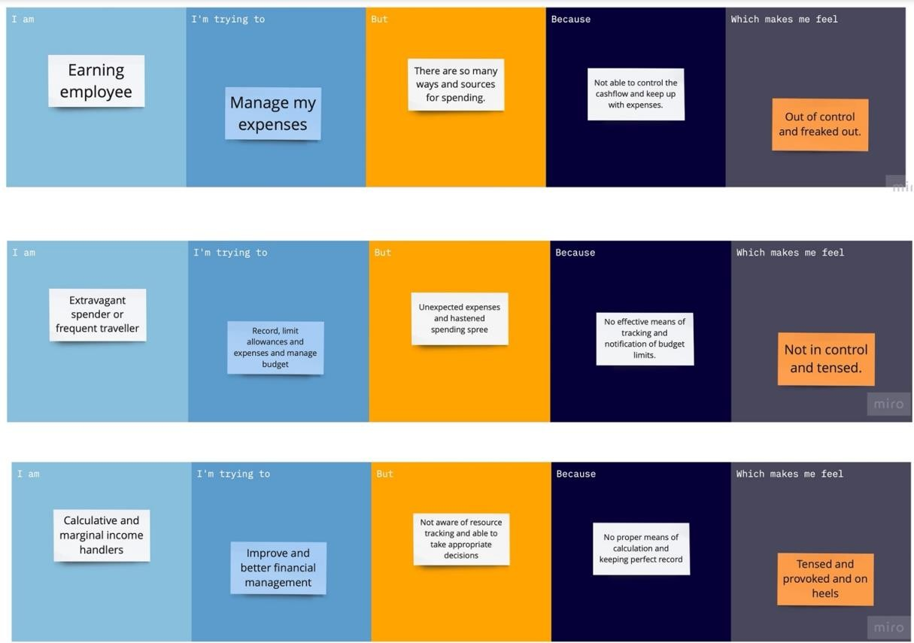

|  |  |  |  |  |  |
| --- | --- | --- | --- | --- | --- |
| **Problem**  **Statement (PS)** | **I am**  **(Customer)** | **I’m trying to** | **But** | **Because** | **Which makes me feel** |
| PS-1 | Earning employee | Manage my expenses | There are so many ways and sources for spending | Not able to control the cash flow and keep up with the  expenses | Out of control and freaked out. |
| PS-2 | Calculative and marginal income handlers | Improve and better at financial management | Not aware of resources tracking and able to take appropriate  decisions | No proper means of calculation and keeping perfect record | Tensed and provoked and on heels |
| PS-3 | Extravagant spender or frequent traveler Extravagant spender or frequent  traveler | Record, limit allowances and expenses and manage budget | Unexpected expenses and hastened spending spree | No effective means of tracking and notification of budget limits. | Not in control and tensed. |